Motives for Capital Crimes, According to the Account of the Criminal Justice Administration

By M. Guerry, *Annals of Public Hygiene and Legal Medicine* , **8** , 335–346

Of all the parts of criminal statistics, perhaps the most important is that which aims to make known the motives of crimes, at least as far as they emerge from the investigation and the debates; unfortunately it is at the same time one of those which offer the most difficulties, and which until now have been the least studied. The table of the patterns, which we have drawn up from the records of the five years 1826 -27-28-29 and 1830, is undoubtedly incomplete. The division could be more methodical, and each article, instead of being reduced to a simple enunciation, should form a chapter and present the numerous developments. Imperfect as it is, this table nevertheless offers results worthy of attention. It also serves to fix ideas, and to mark the starting point for further research. It will be observed, moreover, that the readings having only been made for five years, the various numerical reports are not here of rigorous exactness, but that they only indicate tendencies.

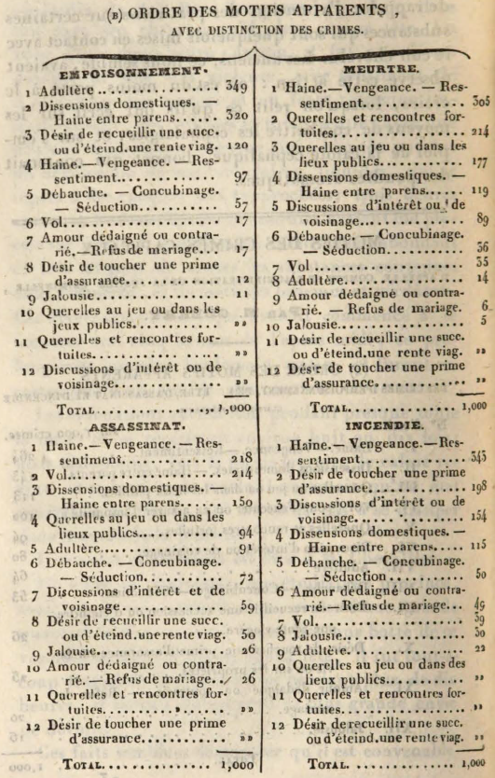

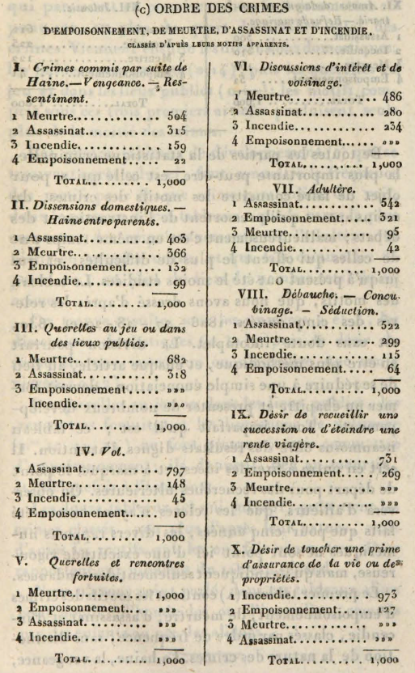

The first table (A) contains the motives for the crimes of poisoning, murder, assassination and arson, listed in order of frequency, without distinguishing the nature of the crimes. Hate and revenge, which appear to be in the first order, cause 26 per cent, or more than a quarter of the total number of crimes, to be committed. Next come domestic dissension, hatred between parents (0.14); then quarrels at play and in public places (0.11); the motives comprised under these first three articles alone produce more than half of the crimes. The four development charts (B) after this one show the frequency of motives for each particular crime. We see, in the first of these tables, that the most common cause of poisoning is adultery, which comes in the first order, and which causes 35 per cent, or more than a third of the total number of these crimes to be committed.

We then find, under numbers 2 and 3, domestic dissensions (0.32); then the desire to collect an estate or extinguish a life annuity (0.12).

Quarrels at play or in public places, chance encounters and neighborhood discussions (Nos. 10, 11, 12) almost never lead to poisoning; they give rise to murder, and sometimes to assassination.

The twelve tables (C) which follow, present the crimes classified, no longer according to their nature, but according to the motives which caused them to be committed. They refer to the numbers in the general table.

We have not spoken, in these tables, of a small number of homicides or fires, committed by children or by the insane.

## Crimes of poisoning, murder and assassination, committed as a result of adultery

(Development chart.)

When, as a result of adultery, an attempt is made against the life of one of the two spouses, one can suppose that it is often the outraged spouse who takes revenge on the guilty spouse. However, this is almost never the case. Out of a hundred attacks of this kind, there are none. has no less than ninety-six against the outraged husband; it should also be noted that this relationship applies to both spouses at the same time. If we consider only the adulterous husband, we see with astonishment that his life is never threatened, the small proportion of four per cent, belonging only to the unfaithful wife, who is half as often struck by her own accomplice as by the husband she betrays.

It is sad to think that he who, in the world, has sometimes been made to expiate by scandalous mockery for faults which he has not committed, is precisely the one who has the most to fear for his life. The crimes of which he is the object form nearly three-quarters of those caused by adultery. Attempts on the life of the husband are the most frequent; they amount to three-fifths of the total number; those which are directed against women account for two-fifths only.

Attacks on the outraged husband occur in this order: they are committed, first by the accomplice alone, by the accomplice and the wife, by the wife alone, then by the wife and a third party. More than three-fifths of the attempts on the life of outraged women are committed directly by the adulterous husband; a fifth is committed by the husband's accomplice; about another fifth, by the husband and his accomplice.

If the life of adulterous spouses is almost never threatened, the same is not true of that of their accomplices, which moreover is almost three times less exposed than that of outraged spouses.

The accomplice of the adulterous husband is three times less often the victim than the accomplice of the wife. The latter usually perishes by the hand of the husband, sometimes also by the hand of the wife or that of her relatives. It is remarkable, in fact, that when relatives find themselves involved in these bloody debates, they are constantly directed by honorable motives: if they appear, it is always to put an end to the disorders which trouble the family, and to avenge the cheated husband. They then strike infallibly, not their parent who betrays his duties, but his accomplice.

After spouses and accomplices, children are the first victims. · First those who are the fruit of an adulterous trade, then those who are born of a legitimate union. The first are killed by the mother who wants to make the trace of her fault disappear, or by the husband to avenge his injury; the others, objects of aversion or jealousy, and whose inheritance is coveted by favorite children, are struck by the adulterous spouse and his accomplice.

## Crimes of poisoning, murder and assassination, committed as a result of debauchery, seduction and concubinage.

(Development chart.)

Debauchery, seduction and concubinage cause almost as many crimes to be committed as adultery.

We have seen that in adultery it is man's life that is most often threatened. Here it's the opposite; by a sort of compensation, more than three-quarters of the attacks are directed against women. His days are therefore twice as exposed as those of the man.

The desire to forestall a complaint after an indecent assault, and thus to escape scandal and the dangers of a criminal trial, is the most common motive for attacks on the lives of women; alone it produces about a quarter of it.

A sixth of these crimes is then committed to avenge him on unfaithful concubines or who want to break guilty habits; another 6th to get rid of seduced women or abandoned lovers who become an obstacle to the marriage of the accused. A sad consequence of such liaisons! Whether constant or unfaithful, the seduced woman has no fewer dangers to fear.

Some of these attacks, about a 17th , are of a particular nature and are committed, so to speak, in complicity with the unfortunate women who are their victims. They result from involuntary poisonings, and from perilous maneuvers intended to determine the abortion and to save oneself a crime for the future.

In marriage, a woman's infidelity causes only about one-thirty-third of the attempts against her life to be committed; it determines the sixth or four times more in illicit unions.

The most common reason for attacks on the life of women, as a result of seduction, debauchery and concubinage, causes a quarter of them to be committed, as we have seen above: the one that mainly determines the attacks on life of men is still more powerful; he causes more than half of them to be committed. It is the desire to avenge seduced relatives. Crimes which, like this one, are not due to a direct and personal interest, are extremely rare, for there are barely two out of a hundred, including also the *vendettas* of Corsica. Half of these crimes are committed by a sudden movement, while defending third parties; the other is, in general, for the motive of which we spoke above, but often also, we must say, with the intention of satisfying the hatred of persons with whom the accused maintained illicit liaisons.

About a 33 rd of attacks on the life of men, always as a result of seduction, debauchery and concubinage, are committed in places of prostitution. It is almost always there that the prostitutes are struck, when one takes their own life.

To complete this picture of the evils brought about after him by the disorder of morals, to this frightening series of attacks, we should still add, about the 14th of the fires whose motives are known, a large number of duels, alienations mental, especially among prostitutes, all infanticides, then finally, for the capital, most suicides committed by young women.

From these facts we are led to considerations which doubtless will not have escaped the reader. Today, when beliefs are weakened, when the old principles of private conduct, at least those which do not directly affect material and pecuniary interests, are shaken and called into question, the connections that morality condemns are seen above all with a extreme indulgence; the theater and light literature, by constantly presenting them as excusable errors, tend to mislead public opinion still further and to make it, if possible, less severe. However, if we abandon the principle of duty for that of interest or utility; that in our eyes the morality of an action results, not from its own nature, but solely from its consequences, our conduct must always remain the same. We are forced to recognize that assessed only on this new basis, such liaisons do not become less serious offenses than they were in the doctrine which is rejected as insufficient and founded on vain prejudices. In studying the relations of man in society, we will always find that the ideas of true utility and of duty, far from ever being opposed, merge and are inseparable.

Readers of our Annals more than the other, for it offers not only the results of the year for which it was written. Thus, we see there a parallel between the period from 1821 to 1825, and that from 1826 to 1830, from which it results that,

At the Hôtel-Dieu in Lyon, the mortality of the so-called civilian patients was, on average, one in eight, 64/100 during the years 1821 to 1825, and one in seven, 74/100 during the years 1826. at 1830; while for the military, it was, during the same five-year periods, only one out of twenty-six 25/100 and twenty-four 28/100.

These proportions are provided by one hundred and twenty-nine thousand eighty-nine civilian patients and by twenty-seven thousand nine hundred and eighty-three military patients.

At the Hospice de la Charité in the same town, one death has been counted annually,

Out of five 12/100 old and incurable persons, from 1821 to 1825, and out of three 24/100 from 1826 to 1830;

Out of five 03/100 and out of nine 70/100 children under the age of twelve and kept in the home;

Out of ten 64/100 and eleven 20/100 children placed in the countryside;

And out of forty-four 51/100 and forty-nine 26/100 pregnant, in childbirth or nursing girls.

These last facts are given by two thousand four hundred sixty-three old and incurable people, twenty-three thousand one hundred seventy-five children kept in the house, and by twenty thousand eight hundred sixty-nine, pregnant girls, in childbirth or nurses.

ON THE DIFFERENT RELATIONSHIP OF THE TWO SEXES IN LEGITIMATE AND ILLEGITIMATE BIRTHS .

I. Letter from Professor Charles BABBAGE to the Honorable MT-P. COURTENAY, on the ratio of the two sexes, in births.

He. Of the effect of legitimacy on the ratio of births of different sexes; by Mr. P. PREVOST.

Ill. Research on the ratio of the two sexes in births; by Captain BICKES

Mr. Babbage's letter appeared in the Edinburgh Science Journal (1) issue of July 1829.

You know, it says, this curious fact, established in the Annuaire du bureau des longitudes de Paris, that the excess of births of boys over those of girls is greater for legitimate children than for children born outside marriage. We see there that for 10,000 girls who come into the world, we must count in France 10,657 boys in legitimate births, and only 10,484 in illegitimate pastures. This difference deserves great attention: I therefore thought it useful to investigate whether or not it is reproduced in other countries.

We must very much regret, in this respect, that sufficiently exact and proper enumerations to ascertain it have not been made everywhere, and that, when these enumerations have taken place, the results have not always been published, or even though they have been hidden from the public. A volume of statistical documents, as valuable as they are varied, has indeed appeared in the kingdom of Naples for the year 1824; but it is so far an isolated publication; and there should be a similar one every year. ...

It results from my documents, on this kingdom, less Sicily, that the births of boys, were as follows, if we reduce all that of girls to 10,000:

* Table here

Consequently, for four years out of the five, the surplus of boys was greater here for children born in marriage than for the others. It is therefore in the kingdom of Naples as in France: this result is based for France on 9,656,000 legitimate births, and 673,000 illegitimate, and for the kingdom of Naples, on 1,059,000 of the first and 51,300 of the second. Let us observe, moreover, with regard to 1819, that is to say, the exceptional year, that an average given by numbers that are too small is often very different from that which would be given by a considerable quantity of facts.

The following table, which results from information furnished by Mr. Hoffman, director or president of the offices of statistics of Berlin, shows the ratio of the two sexes in the legitimate illegitimate births of Prussia, during a period of eight consecutive years:

* Table here

According to documents communicated by M. Hassel , head of division and director of the statistical office at the ministry of the interior of the former kingdom of Westphalia, one would have counted, in this country, for 10,000 girls:

* Table here

Consequently, it is in the provinces of Westphalia that the excess of boys over girls among legitimate children is most marked. It is true that the other children here do not amount to 20,000. This number alone would not suffice for us to be able to deduce a certain conclusion from it; but when we compare this conclusion with that which is deduced from the preceding numbers, it acquires a very great value.

Finally, he was born in Montpellier, for twenty consecutive years, from 1772 to 1792, namely:

* Table here

It is therefore well proven that the excess of boys over girls is less considerable in births outside marriage than in legitimate births. This results from more than fourteen million children of this last class, and from more than a million so-called natural children, taken not only as a whole, but also (which proves more) in each of the five fractions which form these fifteen to sixteen million total births.

We cannot attribute the generality of the fact in question to the climate; for the sky of Naples differs greatly from that of France, and nothing less resembles the marshes of Westphalia than the sands of Brandenburg or part of Prussia.

* There follows more text and tables of births, legitimate and illegitimate, male and female in different regions. These are not included in this translation.